DC-to-AC Converter
23 May 2017
7:31

A power inverter, or inverter, is an electronic device or circuitry that changes direct current (DC) to alternating current (AC). A power inverter can be entirely electronic or may be a combination of mechanical effects (such as a rotary apparatus) and electronic circuitry. Static inverters do not use moving parts in the conversion process.
The input voltage , output voltage and frequency, and overall power handling depend on the design of the specific device or circuitry. The inverter does not produce any power; the power is provided by the DC source. Figure below shows Basic DC-AC Inverter Block Diagram.

A typical power inverter device or circuit requires a relatively stable DC power source capable of supplying enough current for the intended power demands of the system. The input voltage depends on the design and purpose of the inverter. Figure below shows the Configuration of Electric Vehicle.

In figure above it can be seen that the traction motor requires AC input. The main source of electrical power is the battery which is a DC source. The DC output of the battery is bucked or boosted according to the requirement and then converted into AC using a DC-AC inverter. The function of an inverter is to change a dc input voltage to a symmetric ac output voltage of desired magnitude and frequency. The output voltage waveforms of ideal inverters should be sinusoidal. However, the waveforms of practical inverters are non-sinusoidal and contain certain harmonics.

HALF BRIDGE DC-AC INVERTER
A single phase Half Bridge DC-AC inverter is shown in Figure below,
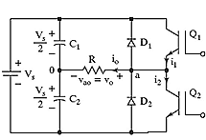
The analysis of the DC-AC inverters is done taking into accounts the following assumptions and conventions.
1) The current entering node a is considered to be positive.
2) The switches S1 and S2 are unidirectional, i.e. they conduct current in one direction.
3) The current through S1 is denoted as i1 and the current through S2 is i2.
The switching sequence is so design is shown in Figure below. Here, switch S1 is on for the time duration 0 ≤ t ≤ T1 and the switch S2 is on for the time duration T1 ≤ t ≤ T2. When switch S1 is turned on, the instantaneous voltage across the load is ν o = Vin/ 2
When the switch S2 is only turned on, the voltage across the load is
ν o = ̶ Vin/ 2.
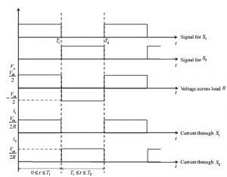
The r.m.s value of output voltage ν o is given by,
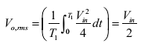
The instantaneous output voltage ν o is rectangular in shape. The instantaneous value of ν o can be expressed in Fourier series as,
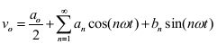
Due to the quarter wave symmetry along the time axis , the values of a0 and an are zero. The value of bn is given by,
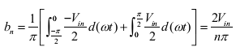
Substituting the value of bn from above equation 5, we get
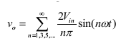
The current through the resistor ( iL ) is given by,
Half Bridge DC-AC Inverter with L Load and R-L Load
The DC-AC converter with inductive load is shown in Figure below. For an inductive load, the load current cannot change immediately with the output voltage.
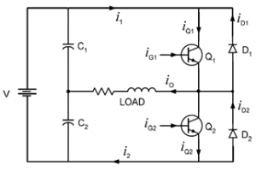
The working of the DC-AC inverter with inductive load is as follow is:
Case 1: In the time interval 0<=t<= T1 the switch S1 is on and the current flows through the inductor from points a to b. When the switch S1 is turned off (case 1) at t-T1, the load current would continue to flow through the capacitor C2 and diode D2 until the current falls to zero, as shown in Figure below.
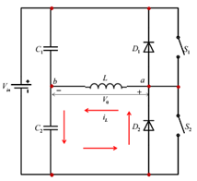
Case 2: Similarly, when S2 is turned off at t = T1 , the load current flows through the diode D1 and capacitor C1until the current falls to zero, as shown in Figure below.
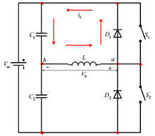
When the diodes D1 and D2 conduct, energy is feedback to the dc source and these diodes are known as feedback diodes. These diodes are also known as freewheeling diodes. The current for purely inductive load is given by,
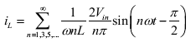
Similarly, for the R – L load. The instantaneous load current is obtained as,
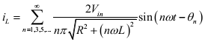
Where,
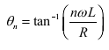

THREE PHASE INVERTER
The 3-phase bridge type VSI with square wave pole voltages has been considered. The output from this inverter is to be fed to a 3-phase balanced load. Figure below shows the power circuit of the three-phase inverter. This circuit may be identified
as three single-phase half-bridge inverter circuits put across the same dc bus. The individual pole voltages of the 3-phase bridge circuit are identical to the square pole voltages output by single-phase half bridge or full bridge circuits. The three pole voltages of the 3-phase square wave inverter are shifted in time by one third of the output time period.
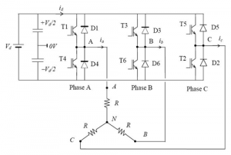
Voltage and Current Ratings of Inverter Switches
As in a single-phase square-wave inverter, switches in each leg of the three-phase inverter operate in a complementary manner. When upper switch of a leg is on the lower switch will need to block the entire dc bus voltage and vice versa. Thus the switches must be rated to block the worst-case instantaneous magnitude of dc bus voltage. Hence the switches must be rated to withstand the peak expected magnitude of instantaneous load-phase current. For a non-unity power factor load, the diode connected in anti-parallel with the switch will conduct part of the switch current. The distribution of current between the diode and the controlled switch will depend on the load power factor at the operating frequency. In general both diode as well as the controlled switch should be rated to carry the peak load current. These diodes also need to block a peak reverse voltage equal to worst case voltage across the switches.
Limitations of 3-Phase Square Wave Inverter:
The three-phase square wave inverter as described above can be used to generate balanced three-phase ac voltages of desired (fundamental) frequency. However harmonic voltages of 5th, 7th and other non-triplen odd multiples of fundamental frequency distort the output voltage. In many cases such distortions in output voltages may not be tolerable and it may also not be practical to use filter circuits to filter out the harmonic voltages in a satisfactory manner. In such situations the inverter discussed in this lesson will not be a suitable choice. Fortunately there are some other kinds of inverters, namely pulse width modulated (PWM) inverters, which can provide higher quality of output voltage. The square wave inverter discussed in this lesson may still be used for many loads, notably ac motor type loads. The motor loads are inductive in nature with the inherent quality to suppress the harmonic currents in the motor.
The example of a purely inductive load discussed in the previous section illustrates the effectiveness of inductive loads in blocking higher order harmonic currents. In spite of the inherent low-pass filtering property of the motor load, the load current may still contain some harmonics. These harmonic currents cause extra iron and copper losses in the motor. They also produce unwanted torque pulsations. Fortunately the torque pulsations due to harmonic currents are of high frequencies and their effect gets subdued due to the large mechanical inertia of the drive system. The motor speed hardly changes in response to these torque pulsations.
However in some cases torque pulsations of particular frequencies may cause unwanted resonance in the mechanical system of the drive. A special notch filter may then be required to remove these frequencies from the inverter output voltage. The input dc voltage to the inverter is often derived from an ac source after rectification and filtering. A simple diode bridge rectifier followed by a filter capacitor is often the most cost-effective method to get dc voltage from ac supply. In some applications, like in un-interrupted power supplies, the dc input may be coming from a bank of batteries. In both these examples, the input dc magnitude is fairly constant. With fixed input dc voltage the square-wave inverter can output only fixed magnitude of load voltage. This does not suit the requirement in many cases where the load requires a variable voltage variable frequency (VVVF) supply. In order that ac output voltage magnitude is controllable, the inverter input voltage will need to be varied using an additional dc-to-dc converter. However a better solution will be to use a PWM inverter which can provide a VVVF output with enhanced output voltage quality. In spite of the limitations, discussed above, the square wave inverter may be a preferred choice on account of its simplicity and low cost. The switch control circuit is very simple and the switching frequency is significantly lower than in PWM inverters.
This results in low switching losses. The switch cost may also be lower as one may do away with slower switching devices and slightly lower rated switches. Another advantage over PWM inverter is its ability to output higher magnitude of fundamental voltage than the maximum that can be output from a PWM inverter.
Applications of a 3-phase square wave inverter
(i) A low cost solid-state frequency changer circuit: This circuit converts the 3-phase ac (input) voltages of one frequency to 3-phase ac (output) voltages of the desired frequency. The input ac is first converted into dc and then converted back to ac of new frequency. The square wave inverter discussed in this lesson may be used for dc to ac conversion. Such a circuit may, for example, convert 3-phase ac voltages of 50 Hz to 3-phase ac voltages of 60 Hz. The input to this circuit could as well have come from a single-phase supply, in which case the single-phase ac is first converted into dc and then converted back to 3-phase ac of the desired frequency.
(ii) An uninterrupted power supply circuit: Uninterrupted power supply circuits are used to provide uninterrupted power to some critical load. Here a critical load requiring 3-phase ac supply of fixed magnitude and frequency has been considered. In case ac mains supply fails, the 3-phase load may be electronically switched, within few milliseconds, to the output of the 3-phase square wave inverter. Input dc supply of the inverter often comes from a battery bank.
SINGLE PWM INVERTERS
The Pulse Width Modulation (PWM) is a technique which is characterized by the generation of constant amplitude pulse by modulating the pulse duration by modulating the duty cycle. Analog PWM control requires the generation of both reference and carrier signals that are feed into the comparator and based on some logical output, the final output is generated. The reference signal is the desired signal output maybe sinusoidal or square wave, while the carrier signal is either a sawtooth or triangular wave at a frequency significantly greater than the reference.
The DC to AC power converters are known as Inverters. An inverter is a circuit which converts a dc power into an ac power at desired output voltage and frequency. The ac output voltage could be fixed or variable frequency. This conversion can be achieved either by controlled turn on and turn off devices (e.g. BJT’s, MOSFETs, IGBTs, MCTs, SITs, GTOs, and SITHs) or by forced commutated thyristors, depending on applications. The output voltage waveforms of ideal inverter should be sinusoidal.
The voltage waveforms of practical inverters are, however, nonsinusoidal and contain certain harmonics. Square wave or quasi-square wave voltages are acceptable for low and medium power applications, and for high power applications low, distorted, sinusoidal waveforms are required. The output frequency of the inverter is determined by the rate at which the semiconductor devices are switched on and off by the inverter control circuitry and consequently, an adjustable frequency ac output is readily provided.
The square wave inverters need switching devices. These switching devices can either be thyristors or transistors and or other power semiconductor devices. Due to their mode of operation, losses in these semiconductor devices are very small and consequently they have a higher efficiency with much more power handling capability. There are three basic configurations of single phase square wave inverters are centre – tapped load, centre -tapped supply and bridge configuration.
By sequentially switching them on and off, the voltage across the load changes polarity cyclically and produces an alternating voltage / current. The main drawback of the centre-tapped configuration is that it needs a centre-tapped transformer/supply and higher voltage ratings transistors. This limitation can be overcome by bridge type inverters. In bridge inverters, there are four transistors for single phase operation instead of two as in centre-tapped inverters. The transistors are operated in such way that when T1 is on, T4 is off and vice-versa.
Similarly, transistors T2 and T3 are switched in a complementary manner. When transistors T1 and T2 conduct, a positive voltage appears across the load and when T3 and T4 conduct, a negative voltage is developed. If the time periods of T1 and T2 are analogous with those of T3 and T4, a square wave is produced across the load. However, if the switching of T1, T2 and T3, T4 is shifted in phase, the width of the positive and negative halves is controlled and the voltage across the load is controlled.
Pulse width modulated (PWM) inverters are among the most used power-electronic circuits in practical applications. These inverters are capable of producing ac voltages of variable magnitude as well as variable frequency. The quality of output voltage can also be greatly enhanced, when compared with those of square wave inverters. The PWM inverters are very commonly used in adjustable speed ac motor drive loads where one needs to feed the motor with variable voltage, variable frequency supply.
For wide variation in drive speed, the frequency of the applied ac voltage needs to be varied over a wide range. The applied voltage also needs to vary almost linearly with the frequency. PWM inverters can be of single phase as well as three phase types. The PWM inverters are very commonly used in adjustable speed ac motor drive loads where one needs to feed the motor with variable voltage, variable frequency supply.
For wide variation in drive speed, the frequency of the applied ac voltage needs to be varied over a wide range. The applied voltage also needs to vary almost linearly with the frequency. PWM inverters can be of single phase as well as three phase types.
Power Circuit :-
The power circuit of Single Phase Unipolar inverter consists of four bidirectional IGBT arranged in bridge form. The circuit diagram of the power circuit is shown in Figure below.
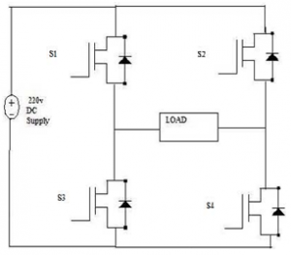
The circuit diagram consists of four distinct IGBTs such that they are connected as the bridge circuit. The input to the circuit is the 220v DC supply from the rectifier unit. The IGBTs are triggered accordingly such that the AC output voltage is obtained at the output. The operation of the circuit is as follows.
First the IGBT S1 and S4 are turned on by triggering the gate of the IGBT. During this time the input supply is 220v DC and at the output the 220v is applied across the load. The current starts from the supply positive, S1, S2, load and to the negative of the supply. The conduction path for the first cycle of operation is shown in figure below.
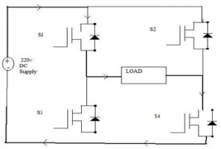
During the next phase or the cycle the IGBT S2 and S3 are turned on by giving trigger pulse to the gate of the IGBTs. During this period the input voltage is applied at the output but in the negative direction. The current conduction starts from the supply, S2, S3, load and to the negative of the supply. The current conduction is showed in the figure below.
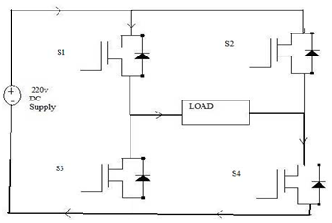
As the two cycles continue the positive and the negative voltage is applied at the load and the current direction changes in the two cycles. As the current direction changes the alternative voltage is obtained at the load thus converting DC.
Applications
  - Uninterruptible Power Supply (UPS).
  - Adjustable Speed Drives (ASD) for ac motors.
  - Electronic frequency changer circuits used in induction heating, welding etc.
  - HVDC transmission at lower power levels.
  - Renewable Energy such as solar, fuel cell to AC conversion.
  - Electronic Ballast and Compact Fluorescent lamps.
  - Active Filters for power quality improvement.
  - Custom power devices: DSTACTCOM, DVR, UPQC, FACTS: STATCOM, SSSC, UPFC, etc.
Advantages
  - Low power consumption.
  - High energy efficient up to 90%.
  - High power handling capability.
  - No temperature variation-and ageing-caused drifting or degradation in linearity.
  - Easy to implement and control.
  - Compatible with today’s digital microprocessors.

Disadvantages
  - Attenuation of the wanted fundamental component of the waveform.
  - Switching devices and therefore derating of those devices.
  - Generation of high-frequency harmonic components.
  - Drastically increased switching frequencies that leads to greater stresses on associated.

